WEB-BASED SALES, INVENTORY, AND REPAIR MANAGEMENT SYSTEM WITH CUSTOMER PORTAL FOR LUCKY LION E-BIKE BRANCHES IN CAVITE

Undergraduate Capstone Project
Submitted to the Faculty of the
Cavite State University – Trece Martires City Campus
Trece Martires City, Cavite

In partial fulfillment
of the requirements for the degree
Bachelor of Science in Information Technology

MARK DAVE L. MENESES
RAYMOND R. SADSAD

2026

WEB-BASED SALES, INVENTORY, AND REPAIR MANAGEMENT SYSTEM WITH CUSTOMER PORTAL FOR LUCKY LION E-BIKE BRANCHES IN CAVITE
Mark Dave L. Meneses
Raymond R. Sadsad
An undergraduate capstone project manuscript presented to the faculty of the Department of Information Technology, Cavite State University – Trece Martires City Campus, Trece Martires City, Cavite, in partial fulfillment of the requirements for the degree of Bachelor of Science in Information Technology. Contribution No. ___. Prepared under the supervision of Asst. Prof. Pamela Daphne R. Busog.
Introduction
The electric bicycle (e-bike) has become one of the most widely adopted modes of personal transportation in the Philippines, and the Province of Cavite is among the regions where this shift is most visible. Rising fuel prices, worsening road congestion, and the affordability of electric two- and three-wheelers have driven strong and sustained demand, with national unit sales of electric two-wheelers climbing from roughly 36,000 units in 2020 to about 84,000 units in 2025 (Ken Research, 2025). This growth has been reinforced by Republic Act No. 11697, otherwise known as the Electric Vehicle Industry Development Act (EVIDA), which provides the national policy framework promoting the manufacture, importation, and use of electric vehicles across the country and signals a long-term government commitment to electric mobility (Official Gazette of the Republic of the Philippines, 2022). Lucky Lion E-Bike is a growing local enterprise that rides this wave of demand. From a single store, it has expanded into a network of nine branches spread across the province — its main branch along the Emilio Aguinaldo Highway in Buhay na Tubig, Imus, together with branches in Imus (Robinsons), Trece Martires, Tanza, Naic, Tejero in General Trias, General Mariano Alvarez (GMA), Silang, and San Roque in Naic. As the number of branches, customers, and units sold continues to rise, the volume of information the business must keep track of has grown well beyond what its original, store-by-store record-keeping was ever designed to handle.
As the business expanded from a single store into a multi-branch network, its day-to-day operations continued to rely on manual and fragmented methods that were never intended for an organization of its present size. Customer records, the serial numbers of the units each buyer owned, and repair appointments were written down in notebooks or kept in separate spreadsheets maintained independently by each branch, while inquiries reached the shop only through walk-ins, phone calls, and scattered social-media messages that were easy to overlook or lose. Because every branch kept its own records in isolation, management had no consolidated, real-time view of the company's customers, of the units that had been sold across the network, or of the after-sales service each unit had received. Customers, in turn, had no reliable online way to browse the current catalog, learn which models and colours were offered, locate the branch nearest to them, keep a personal record of the e-bikes they owned, or book a repair without physically visiting or telephoning the store. The result was duplicated effort, records that could not easily be cross-checked between branches, and a customer experience that lagged behind the online convenience that buyers had come to expect.
These gaps are the same operational problems that web-based business systems have repeatedly been shown to solve. Adopting online systems allows small and medium enterprises to reduce operating costs, improve efficiency, reach new customers, and compete with larger and more established businesses (Taylor & Francis, 2021). To address the needs of Lucky Lion E-Bike, this study proposes the development of a Web-Based Sales, Inventory, and Repair Management System with a Customer Portal. The system centralizes the product catalog, customer accounts and the e-bikes each customer owns, the recording of every unit sold, online repair scheduling, and customer–branch messaging behind a single cloud database that all nine branches share, while giving staff and administrators role-based tools to manage each branch and to monitor the business as a whole. Because it handles personal customer information and detailed unit records, the system is secured through encryption — transmitting all data over HTTPS/TLS and storing passwords and other sensitive fields using strong hashing and encryption rather than in readable form (OWASP Foundation, 2024a; OWASP Foundation, 2024b).
Project Context
Managing a multi-branch retail and service business without a shared information system creates problems that grow with every new branch that opens. For Lucky Lion E-Bike, the customers, the units they have purchased, and the repairs those units require are now spread across nine separate locations, yet the records that describe them have historically lived only in the branch that created them. Without a consolidated view, management cannot readily determine how many customers the company serves, which units have been sold and to whom, or how each branch is performing in its after-sales service. The problem is made sharper by the nature of the product: each e-bike sold is an individual physical unit with its own colour and its own chassis, battery, and motor serial numbers, and these details must be recorded accurately so that ownership can be proven, warranty and service claims can be honoured, and a stolen or disputed unit can be identified. After-sales service is equally difficult to coordinate under the old arrangement, because repair requests arrive informally through calls and messages, appointments are written down by hand, and neither the customer nor the branch keeps a clear, retrievable record of the servicing that a particular unit has already received.
At the same time, customers increasingly expect to be able to transact online. They want to browse a store's catalog, view model specifications and the colours available, know which branch is nearest to them, keep a record of the e-bikes they have purchased, and arrange servicing from their phones at any hour rather than only during store hours. Meeting these expectations requires a modern web platform rather than a single-store, offline record book. The researchers, as Bachelor of Science in Information Technology students of Cavite State University – Trece Martires City Campus, identified that a centralized, cloud-hosted web application is the most practical and affordable solution for Lucky Lion E-Bike: it requires no expensive on-site servers, is reachable from any branch computer or customer smartphone that has a browser and an internet connection, and can present the public with a single, unified storefront while giving each branch its own private working area behind secure, role-based access. This study therefore aims to develop and evaluate such a system for the benefit of the enterprise, its branch staff, and its customers throughout Cavite.
Objectives of the Study
The general objective of the study is to develop a web-based sales, inventory, and repair management system with a customer portal for the branches of Lucky Lion E-Bike in Cavite.
Specifically, the study aims to:
a. design a web-based system that:
1. presents a public catalog and online store of e-bikes organized by wheel type (four, three, and two wheels), where each model is shown with its specifications, photographs, and available colour variants, and where the price of a unit is presented on its dedicated product-detail page;
2. allows customers to create an account, sign in, and manage a “My E-Bikes” record of the units they own, including the colour of each unit and its chassis, battery, and motor serial numbers, so that every owner keeps a complete and portable record of their purchase;
3. enables customers to schedule a repair online, with the system enforcing one booking per time slot per day so that appointments never overlap, and to message their chosen branch directly for inquiries and after-sales support;
4. provides staff with a secure branch portal through which they manage their branch's customers, record and update repair appointments and their status, maintain the branch's entries in the e-bike registry of all units sold, and reply to customer messages;
5. provides administrators with company-wide oversight of all nine branches, repair and messaging analytics that summarise activity across the network, and sole control over the product catalog, store photographs, and site settings, including the creation of staff and administrator accounts; and
6. secures all accounts and records through role-based access control and data encryption, protecting information in transit over HTTPS/TLS and safeguarding passwords and sensitive fields through hashing and encryption at rest;
b. develop the system using the following:
1. HTML, CSS, and JavaScript for the front-end web pages;
2. Supabase (PostgreSQL database and cloud storage) accessed over a REST interface as the backend;
3. Netlify for web hosting and continuous deployment;
4. Visual Studio Code and Git as the development and version-control tools; and
5. a modern web browser on a laptop or smartphone for system access and testing;
c. test the system through unit, integration, and system testing;
d. evaluate the system using an adapted ISO/IEC 25010 evaluation instrument; and
e. prepare an implementation plan.
Purpose and Description
The development of this system will benefit Lucky Lion E-Bike as an enterprise, its branch staff, and its customers across Cavite by replacing manual, per-branch record-keeping with a single, cloud-hosted web platform that every branch shares. It is designed to function both as a public storefront — where anyone can browse the catalog, compare models and colours, view prices on each product's page, and locate the nearest of the company's nine branches — and as an internal management tool through which staff handle their own branch's customers, repair appointments, and sold-unit records, while administrators monitor the business as a whole. Its primary goals are to give management a consolidated, real-time view of the company's customers, sales, and after-sales service across all nine branches; to reduce the lost, duplicated, and inconsistent records that inevitably arise when each branch keeps its own notebooks and spreadsheets; to streamline the scheduling and tracking of after-sales repairs; and to improve the overall customer experience through an accessible online portal that is secured end to end by encryption.
Time and Place of the Study
The study will be conducted for Lucky Lion E-Bike, whose main branch is located along the Emilio Aguinaldo Highway in Buhay na Tubig, Imus City, Cavite, together with its branches in Imus (Robinsons), Trece Martires City, Tanza, Naic, Tejero in General Trias, General Mariano Alvarez (GMA), Silang, and San Roque in Naic, Cavite — nine branches in total across the province. System development, data gathering, testing, and evaluation are scheduled to take place from January 2026 to December 2026.
Scope and Limitation of the Study
The proposed capstone project covers the development of a web-based system that unifies the sales, record-keeping, and after-sales repair operations of Lucky Lion E-Bike's nine branches in Cavite. Within its scope, the system provides a public catalog and online store in which e-bikes are organized by wheel type and presented with their specifications, photographs, colour variants, and prices; customer accounts that include a personal registry of the e-bikes each customer owns together with their serial numbers; online repair scheduling with per-slot availability; a customer–branch messaging channel; a staff branch-management portal; a consolidated e-bike registry of every unit sold across the network; and an administrator dashboard that presents repair and messaging analytics across all branches. Access to these functions is governed by role-based access control that clearly separates customer, staff, and administrator privileges (OWASP Foundation, 2024a), and the system is secured by data encryption, transmitting information over HTTPS/TLS and protecting passwords and sensitive fields through hashing and encryption (OWASP Foundation, 2024a; OWASP Foundation, 2024b). The front end is built with HTML, CSS, and JavaScript, while Supabase (PostgreSQL) provides the cloud database and file storage and Netlify provides secure web hosting.
The study, however, has certain limitations. First, the system is a web application and therefore requires an internet connection and a modern web browser to operate; it is not a downloadable mobile application, although its responsive design allows it to be used comfortably on smartphones as well as on computers. Second, the system records sales and manages customer and unit records but does not process online payments; purchase transactions are still completed in person at the branch, and the system records that a sale has taken place rather than collecting the payment itself. Third, the system focuses on cataloguing the models offered and maintaining a registry of the individual units that have been sold rather than on tracking on-hand stock quantities per branch, so it is a records and service platform rather than a full warehouse-inventory system. Fourth, the separation of one branch's data from another's is enforced at the application level for a prototype deployment rather than as hardened, isolated infrastructure. Fifth, the repair module schedules and tracks appointments and their status but does not replace the physical, in-person mechanical service performed by each branch's technicians. Finally, the system depends on the continued availability of its cloud services (Supabase and Netlify), and ongoing updates by the administrator are required to keep the catalog, prices, colour options, and branch details accurate over time.
Conceptual Framework
The conceptual framework of the study is anchored on the Input–Process–Output (IPO) model, which serves as the blueprint for the systematic development and evaluation of the Web-Based Sales, Inventory, and Repair Management System with Customer Portal for Lucky Lion E-Bike. The Input represents the knowledge, software, and hardware resources required to build the system; the Process represents the Agile development activities carried out by the researchers together with the ISO/IEC 25010 quality evaluation applied to the resulting product; and the Output is the finished, deployed web system placed in the hands of the customers, branch staff, and administrators of Lucky Lion E-Bike's nine Cavite branches.
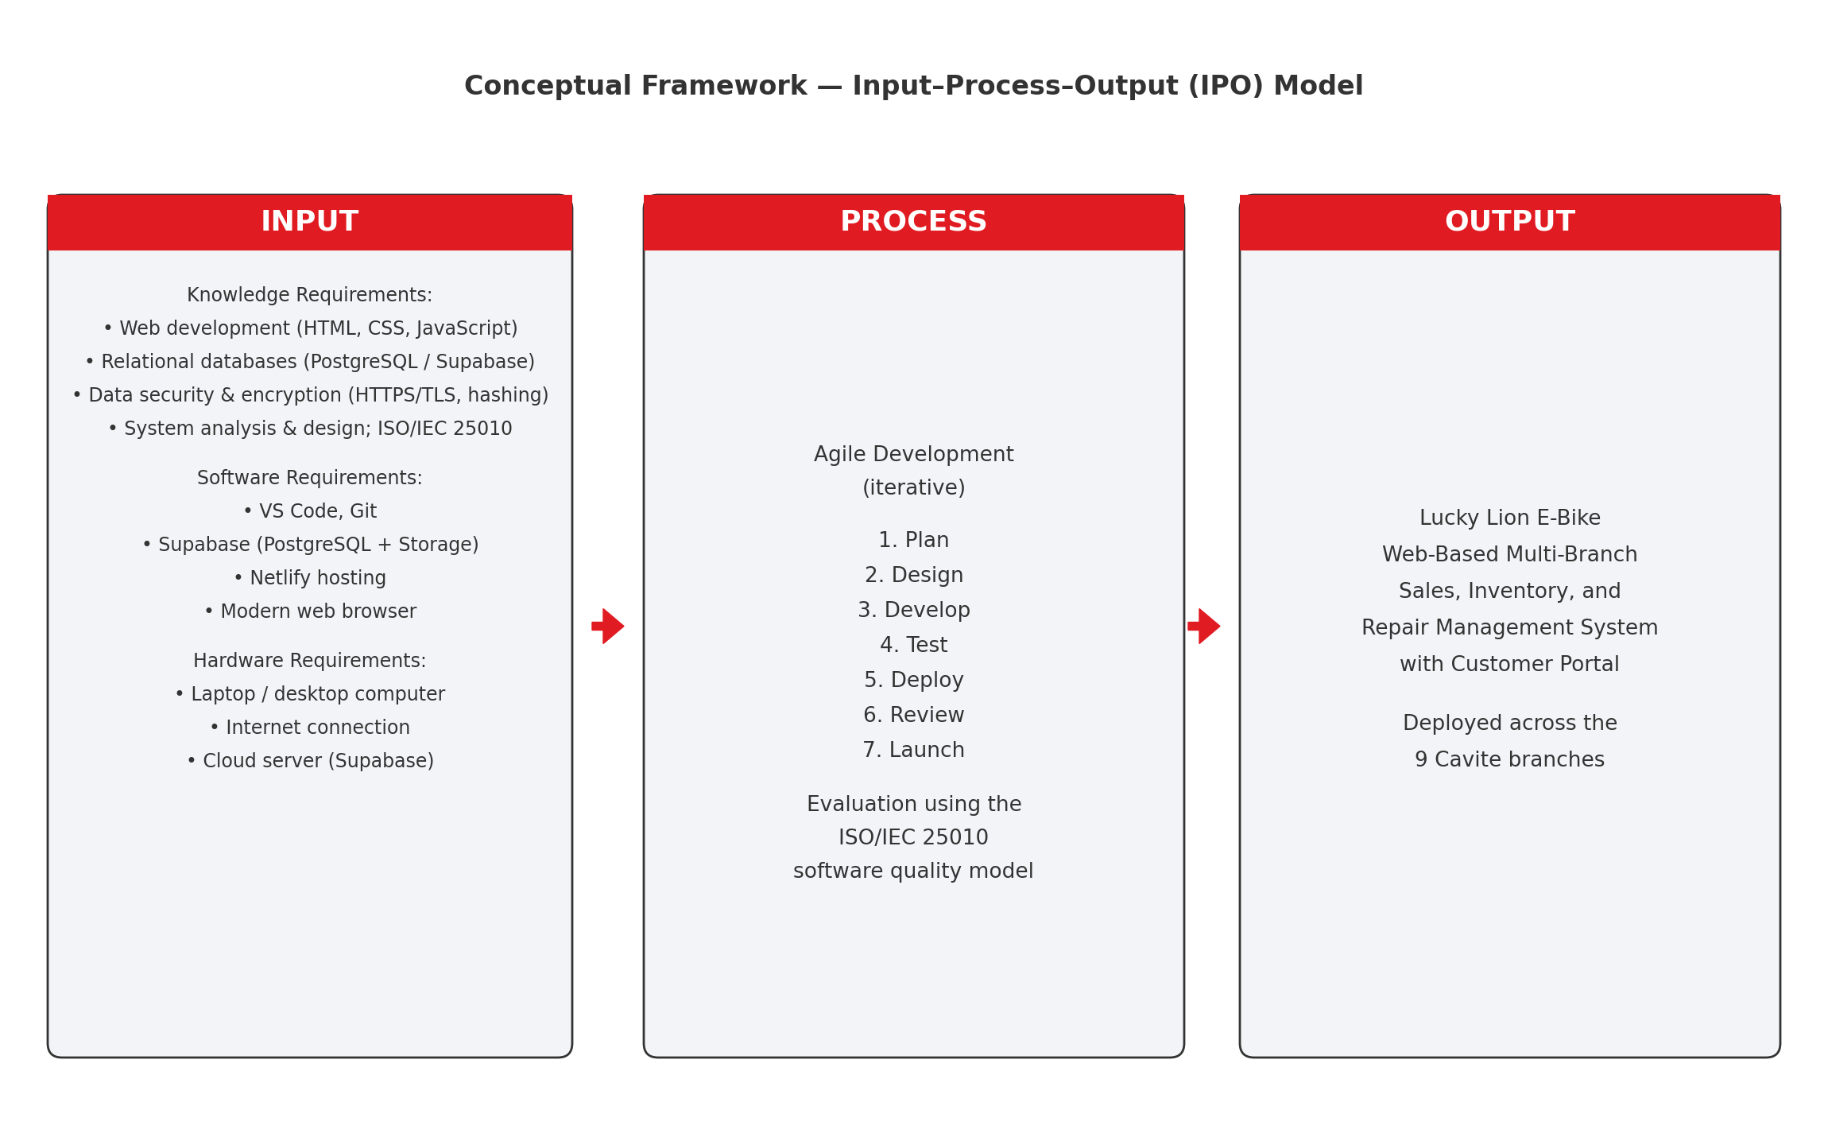
Figure 1. Conceptual framework of the Web-Based Sales, Inventory, and Repair Management System for Lucky Lion E-Bike.
Definition of Terms
The following terms are operationally defined in this study, including simplified explanations for non-technical readers:
Administrator (Admin) is the highest-level user of the system, who oversees all nine branches, reviews company-wide repair and messaging analytics, manages the product catalog and site settings, and creates the staff and administrator accounts used across the organization.
Agile Methodology is a flexible, iterative approach to software development that lets the researchers build and refine the system in repeated cycles based on testing and user feedback.
API (Application Programming Interface) is a defined way for two software programs to exchange data; the system's front end uses Supabase's REST API to read from and write to the database.
Back-End refers to the server-side part of the system — the cloud database and data services on Supabase — that stores information and processes requests coming from the front end.
CSS (Cascading Style Sheets) is the web technology used to control the visual appearance and responsive layout of the system's pages.
Customer Portal is the members' area of the website where a signed-in customer manages a record of the e-bikes they own, schedules repairs, and messages their branch.
Data Encryption is the process of encoding information so that only authorized parties can read it; in this study it protects data in transit (HTTPS/TLS) and sensitive stored data such as passwords, which are hashed rather than kept in plain text.
E-Bike (Electric Bike) is a two-, three-, or four-wheeled vehicle powered by an electric motor and a rechargeable battery, and is the product sold and serviced by Lucky Lion E-Bike.
E-Bike Registry is the consolidated record of every unit sold across all of the branches, listing for each unit its owner, model, colour, and its chassis, battery, and motor serial numbers, so that ownership and service history can be traced from a single source.
Front-End refers to the part of the system that users see and interact with in their web browser, built with HTML, CSS, and JavaScript.
HTML (HyperText Markup Language) is the standard language used to structure the content of the system's web pages.
HTTPS/TLS is the secure protocol that encrypts communication between the user's browser and the system so that data cannot be read or altered while in transit.
Inventory in this study, refers to the organized catalog of e-bike models the business offers together with the consolidated registry of the individual units that have been sold; the system concentrates on cataloguing models and recording sold units rather than on counting on-hand stock at each branch.
IPO Model (Input–Process–Output) is the conceptual framework used to show the inputs (resources), the process (development and evaluation), and the output (the finished system) of the study.
ISO/IEC 25010 is the international standard for software product quality used as the evaluation instrument to measure the system's functional suitability, performance efficiency, compatibility, usability, reliability, security, maintainability, and portability.
JavaScript is the programming language used to make the system's web pages interactive and to exchange data with the Supabase back-end.
Member ID is the unique identifier automatically assigned to each account based on its branch and role, for example TRECE-C-0001 for a Trece-branch customer.
Netlify is the cloud platform used to host and deploy the web system so that it is accessible online.
PostgreSQL is the open-source relational database, provided through Supabase, that stores the system's structured data such as users, models, inventory, and repairs.
REST API is the standardized web interface through which the front end sends and receives data from Supabase over the internet.
Responsive Web Design is a design approach that makes the system adapt to different screen sizes so that it remains usable on both computers and smartphones.
Role-Based Access Control (RBAC) is a security method that grants each user only the functions appropriate to their role — customer, staff, or administrator.
Staff is a branch-level user of the system who manages their own branch's customers, repair appointments, and entries in the e-bike registry, and who replies to the messages sent by that branch's customers.
Supabase is an open-source backend platform built on PostgreSQL that provides the system's database, storage, and data access over the internet, serving as an alternative to Firebase.
Usability is an evaluation of how easy, effective, and satisfying the system is for customers and staff to use.
User Acceptance Testing (UAT) is the phase in which actual staff and customers of Lucky Lion E-Bike test the system to assess its overall quality.
Web Application (Web-Based System) is software that runs in a web browser over the internet rather than being installed on a device; the entire Lucky Lion E-Bike system is a web application.
Review of Related Literature
This chapter presents a systematic review of the literature and studies that provided the conceptual, technical, and legal framework for the development of the Web-Based Sales, Inventory, and Repair Management System with Customer Portal for Lucky Lion E-Bike. By examining the growth of the e-bike industry, the adoption of web-based business systems by small enterprises, and the technologies and standards that underpin secure web applications, the researchers established both the practical need for the system and the academic basis for its design and evaluation.
Related Literature
Growth of the Electric Vehicle Industry in the Philippines. The researchers reviewed Republic Act No. 11697, the Electric Vehicle Industry Development Act (EVIDA), which establishes the national policy framework to promote the manufacture, importation, and adoption of electric vehicles, including e-bikes, in order to reduce the country's dependence on fossil fuels. This legislation confirms that the e-bike market operates within a supportive national policy environment, and market data show that unit sales of electric two-wheelers have risen sharply over recent years, mirroring the rapid global expansion of electric mobility reported by the International Energy Agency. This growth substantiates the commercial relevance of the study: as demand and the number of units on the road increase, retailers such as Lucky Lion E-Bike require better systems to manage sales, stock, and after-sales service. Official Gazette of the Republic of the Philippines (2022); Ken Research (2025); International Energy Agency (2024).
E-Commerce and Web-System Adoption Among SMEs. Recent research on small and medium enterprises confirms that adopting e-commerce and web-based systems yields concrete benefits — cost reduction, improved efficiency, wider market reach, and stronger competitiveness — and that these perceived benefits are primary drivers of adoption. These findings support the premise of this study: that moving Lucky Lion E-Bike's operations onto a web platform is not merely a convenience but a means of improving business performance. The researchers used this to justify designing the system as a public-facing storefront combined with internal management tools rather than a purely internal record system. Taylor & Francis (2021).
Web-Based Inventory Management Systems. The researchers reviewed a study on the development of a web-based inventory management system for small businesses, which demonstrated that centralizing product and record data on a web application improves the accuracy and accessibility of those records and supports better day-to-day operational decisions compared with manual or spreadsheet-based methods. This finding directly informed the record-keeping design of the present system, in which the product catalog and the registry of sold units are centralized in one cloud database shared by every branch, rather than being scattered across the isolated, error-prone notebooks and spreadsheets that a growing multi-branch business would otherwise be forced to maintain. International Journal of Industrial and Production Engineering (2024).
Web-Based Point-of-Sale and Sales Management Systems. Jan, Shah, and Mand described a web-based point-of-sale (POS) system that records sales transactions accurately and improves the speed, reliability, and security of retail operations for small and medium businesses. Their work informed the sales-recording side of the present system, in which assigning a unit to a customer creates a permanent sale record — capturing the buyer, the model, the colour, and the unit's serial numbers — that is then reflected in the company-wide e-bike registry, so that a sale is documented once and remains traceable afterward without any manual re-encoding. Jan, Shah, & Mand (2023).
Customer Relationship Management for SMEs. A systematic review by Matlombe, Vuko, Thango, and Nethanani found that customer relationship management (CRM) systems improve the performance of small and medium enterprises through better customer retention, more consistent communication, and clearer sales tracking. These findings support the customer-facing features of the present system — the customer portal, the direct branch-messaging channel, and the e-bike registry of owned units — which together allow each branch to maintain an organized, ongoing relationship with its customers rather than relying on scattered records and informal, easily lost contact. Matlombe, Vuko, Thango, & Nethanani (2024).
Online Appointment and Booking Systems. Research on online appointment booking, such as the mixed-methods study by Atherton and colleagues, showed that allowing clients to book services online improves convenience and access for the client while reducing the coordination burden on staff, provided that the booking interface is clear and that the available slots are presented accurately. These insights directly shaped the repair-scheduling module of the present system, which allows a customer to book a service appointment online at any time while automatically enforcing a limit of one booking per time slot per day, so that appointments cannot be double-booked and each branch's schedule remains manageable. Atherton, Eccles, Poltawski, Dale, Campbell, & Abel (2024).
Web Application Security and Access Control. The OWASP Cheat Sheet Series provides current, widely accepted guidance on securing web applications, including the OWASP Top 10 catalogue of the most critical web application security risks, the use of role-based access control to grant each user only the functions appropriate to their role, and the safe handling of user credentials. This guidance provided the security foundation for the system's three-tier access design, in which customers, staff, and administrators each see and can act only on the functions permitted to them. OWASP Foundation (2021); OWASP Foundation (2024a).
Data Encryption in Web Applications. OWASP likewise recommends that all traffic be protected in transit using Transport Layer Security (TLS) and that user passwords never be stored in plain text but instead be protected with strong, adaptive hashing algorithms such as bcrypt or Argon2, a practice likewise mandated by national digital-identity standards for the storage of authentication secrets. The researchers adopted these practices as the encryption basis of the system, securing data in transit over HTTPS/TLS and hashing stored credentials, in direct response to the requirement to add encryption. OWASP Foundation (2024b); National Institute of Standards and Technology (2023).
User Acceptance of Information Technology. A 2023 study by Shayan, Rondinelli, van Zaanen, and Atzmueller, applying the technology acceptance model — the framework originally formulated by Davis (1989) — across two system case studies, reaffirmed that the actual use of a system is driven largely by its perceived usefulness and perceived ease of use. This guided the researchers to prioritize a clear, simple interface for both customers and staff, on the premise that a system perceived as useful and easy to use is far more likely to be adopted across Lucky Lion E-Bike's branches; these constructs also align with the usability dimension of the study's evaluation. Shayan, Rondinelli, van Zaanen, & Atzmueller (2023).
Responsive Web Design and Mobile Usability. A study on responsive web design found that adapting a website's layout to different screen sizes significantly improves its usability across devices. Because many of Lucky Lion E-Bike's customers browse from smartphones, the researchers applied responsive design principles so that the public store and customer portal remain usable on both computers and phones, directly addressing the compatibility characteristic of the ISO/IEC 25010 evaluation. The interface was further guided by established usability heuristics and by the Web Content Accessibility Guidelines so that it stays clear and accessible across devices. Education and Information Technologies (2021); Google (2024); Nielsen (2020); W3C Web Accessibility Initiative (2023).
Cloud Databases and Backend-as-a-Service. Supabase is an open-source backend-as-a-service platform built on the PostgreSQL relational database, offering a hosted database, storage, authentication, and data access over a REST interface as an alternative to Firebase. Because it is built on PostgreSQL, it provides the reliability of a relational database with structured schemas and transactional integrity. This architecture allowed the researchers to store the system's users, models, inventory, and repairs in a single cloud database that every branch reads from and writes to in real time, without maintaining a physical on-site server. Supabase (2024).
Relational Databases and Data Integrity. The PostgreSQL documentation describes a mature, open-source relational database that organizes data into related tables governed by keys and constraints that preserve integrity. This model underpins the system's database design, in which entities such as users, models, variants, owned units, and repairs are stored in structured, related tables so that records remain consistent and can be reliably linked — for example, tying each repair and each owned unit to the correct customer and branch. The PostgreSQL Global Development Group (2024).
Web Hosting and Continuous Deployment. Netlify is a cloud platform for building, deploying, and hosting modern web projects, providing automated deployment and delivery of front-end sites secured with HTTPS by default. Its documentation guided the researchers' hosting and deployment approach, enabling the web system to be published and updated efficiently and served securely to customers and staff across all branches. Netlify (2024).
Agile Software Development. A 2023 review by Guerrero-Ulloa, Rodríguez-Domínguez, and Hornos on the application of Agile methodologies emphasizes iterative delivery, responsiveness to change, and continuous collaboration with users — the same values set out in the founding Manifesto for Agile Software Development, in which the system is divided into deliverables that users can check before the whole is completed. The researchers adopted an Agile approach with seven iterative stages so that each module of the system could be built, tested, and refined in cycles with feedback from Lucky Lion E-Bike's staff, ensuring the finished system reflects the real needs of the business. Guerrero-Ulloa, Rodríguez-Domínguez, & Hornos (2023); Beck et al. (2001).
Software Quality Evaluation Using ISO/IEC 25010. ISO/IEC 25010 defines a software product quality model comprising eight characteristics — functional suitability, performance efficiency, compatibility, usability, reliability, security, maintainability, and portability. This standard provided the researchers with a scientific, internationally recognized instrument for evaluating the system, and it forms the basis of the evaluation instrument administered to the study's respondents. International Organization for Standardization (2023).

Table 1 shows a comparison of the proposed system with the methods and tools that Lucky Lion E-Bike and similar businesses currently use to handle sales, inventory, and repair records.
Feature | Proposed Lucky Lion System | Manual / Spreadsheet Records | Generic Social-Media Marketplace | Third-Party Booking App
Web-based access | Yes | No | Yes | Yes
Consolidated multi-branch records | Yes | No | No | No
Public catalog with colour variants | Yes | No | Partial | No
Customer portal (owned-unit registry) | Yes | No | No | No
Online repair scheduling | Yes | No | No | Yes
Customer–branch messaging | Yes | No | Yes | Partial
Role-based access (customer/staff/admin) | Yes | No | No | Partial
Repair & messaging analytics | Yes | No | No | Partial
Data encryption (HTTPS/TLS + hashing) | Yes | No | Partial | Yes
Table 1. Comparison of the proposed system with existing methods across key features.
Systems Technical Background
HTML, CSS, and JavaScript. The front end of the system is built with HTML for structure, CSS for styling and responsive layout, and JavaScript for interactivity and communication with the backend. These are the core, universally supported technologies of the web, allowing the system to run in any modern browser on a laptop or smartphone without installing an application. Their use keeps the system lightweight and accessible to customers and staff alike. Mozilla (2026a, 2026b, 2026c).
Supabase and PostgreSQL. Supabase provides the backend of the system, exposing a PostgreSQL relational database and cloud file storage over a secure REST interface, the resource-oriented architectural style defined by Fielding (2000). PostgreSQL stores the system's structured records — the users, the product models and their colour variants, the owned units, the repairs, and the messages — while Supabase Storage holds the uploaded photographs of the models and the store branches. Because the database is cloud-hosted, all nine branches read from and write to the same single source of truth in real time, so that a change made in one branch is immediately visible to the others. Supabase (2024); The PostgreSQL Global Development Group (2024).
Netlify. Netlify hosts and deploys the web system, serving its pages over HTTPS and enabling the researchers to publish updates efficiently. Hosting the front end on a managed cloud platform removes the need for the business to operate and maintain its own web server. Netlify (2024).
HTTPS/TLS and Data Encryption. Security is implemented following OWASP guidance: all communication between the browser and the backend is encrypted using HTTPS/TLS, and user passwords are protected using strong hashing rather than being stored in readable form, with sensitive fields encrypted at rest. This protects customer information and business records against interception and unauthorized access. OWASP Foundation (2024a); OWASP Foundation (2024b).
Computer and Web Browser. The primary hardware required is a standard laptop or desktop computer for development and administration and any internet-connected device with a modern web browser for everyday use. Because the system is web-based and relies on existing devices owned by the branches and their customers, it is cost-effective and requires no specialized hardware purchase. Supabase (2024).
Synthesis
The reviewed literature and studies collectively establish both the need for and the feasibility of the proposed system. The sustained growth of the e-bike market under a supportive national policy framework confirms the commercial importance of e-bike retail and service in Cavite, while research on the adoption of e-commerce and centralized web-based record systems by small and medium enterprises shows that moving such operations online reduces costs, improves the accuracy and accessibility of records, and strengthens a business's competitiveness. Studies on online appointment booking, role-based access control, and web application security provided concrete design guidance for the repair-scheduling, access-control, and encryption components of the system, and the official documentation of Supabase, PostgreSQL, and Netlify confirmed that a reliable, secure, and cloud-hosted web system can be built and deployed affordably without any on-site servers.
At the same time, the literature highlights challenges that the study must address, including the system's dependence on internet connectivity and cloud services, the need for careful security practices when handling personal customer data, and the importance of clear, genuinely usable interfaces so that both staff and customers are willing to adopt the platform in place of their familiar manual methods. Guided by the Agile methodology throughout its development and evaluated against the internationally recognized ISO/IEC 25010 quality model, the proposed system is positioned to consolidate Lucky Lion E-Bike's multi-branch operations, to improve the coordination of its after-sales service, and to deliver a secure, accessible, and modern online experience to its customers throughout Cavite.
Methodology
This chapter presents the design of the software and processes, the system development approach, the system testing and evaluation procedures, the data analysis plan, and the implementation plan of the study.
Design of Software, Systems, Product and/or Processes
The Web-Based Sales, Inventory, and Repair Management System with Customer Portal provides Lucky Lion E-Bike with an organized, cloud-hosted digital solution that replaces the manual, per-branch record-keeping the business has relied on until now. It presents customers with a single public storefront and a members' portal, while giving staff and administrators secure, role-based tools with which to manage each branch and to monitor the business as a whole, all drawing on one shared database so that the information seen by every user is consistent and current.
Figure 2 shows the hierarchical input–process–output structure of the system. From the public catalog and store, a visitor browses the available e-bike models by wheel type, views their specifications, colours, and prices, and locates a nearby branch; upon creating an account, that visitor becomes a customer who can register the e-bikes they own, schedule a repair, and message a branch directly. Staff sign in to a branch portal through which they manage their branch's customers, record and update repairs, maintain the branch's entries in the e-bike registry, and answer customer messages, while administrators oversee all nine branches, review analytics, and control the product catalog, store photographs, and site settings. All of these functions read from and write to a single Supabase (PostgreSQL) cloud database over a secure connection, with role-based access controlling precisely what each type of user is permitted to see and to do.
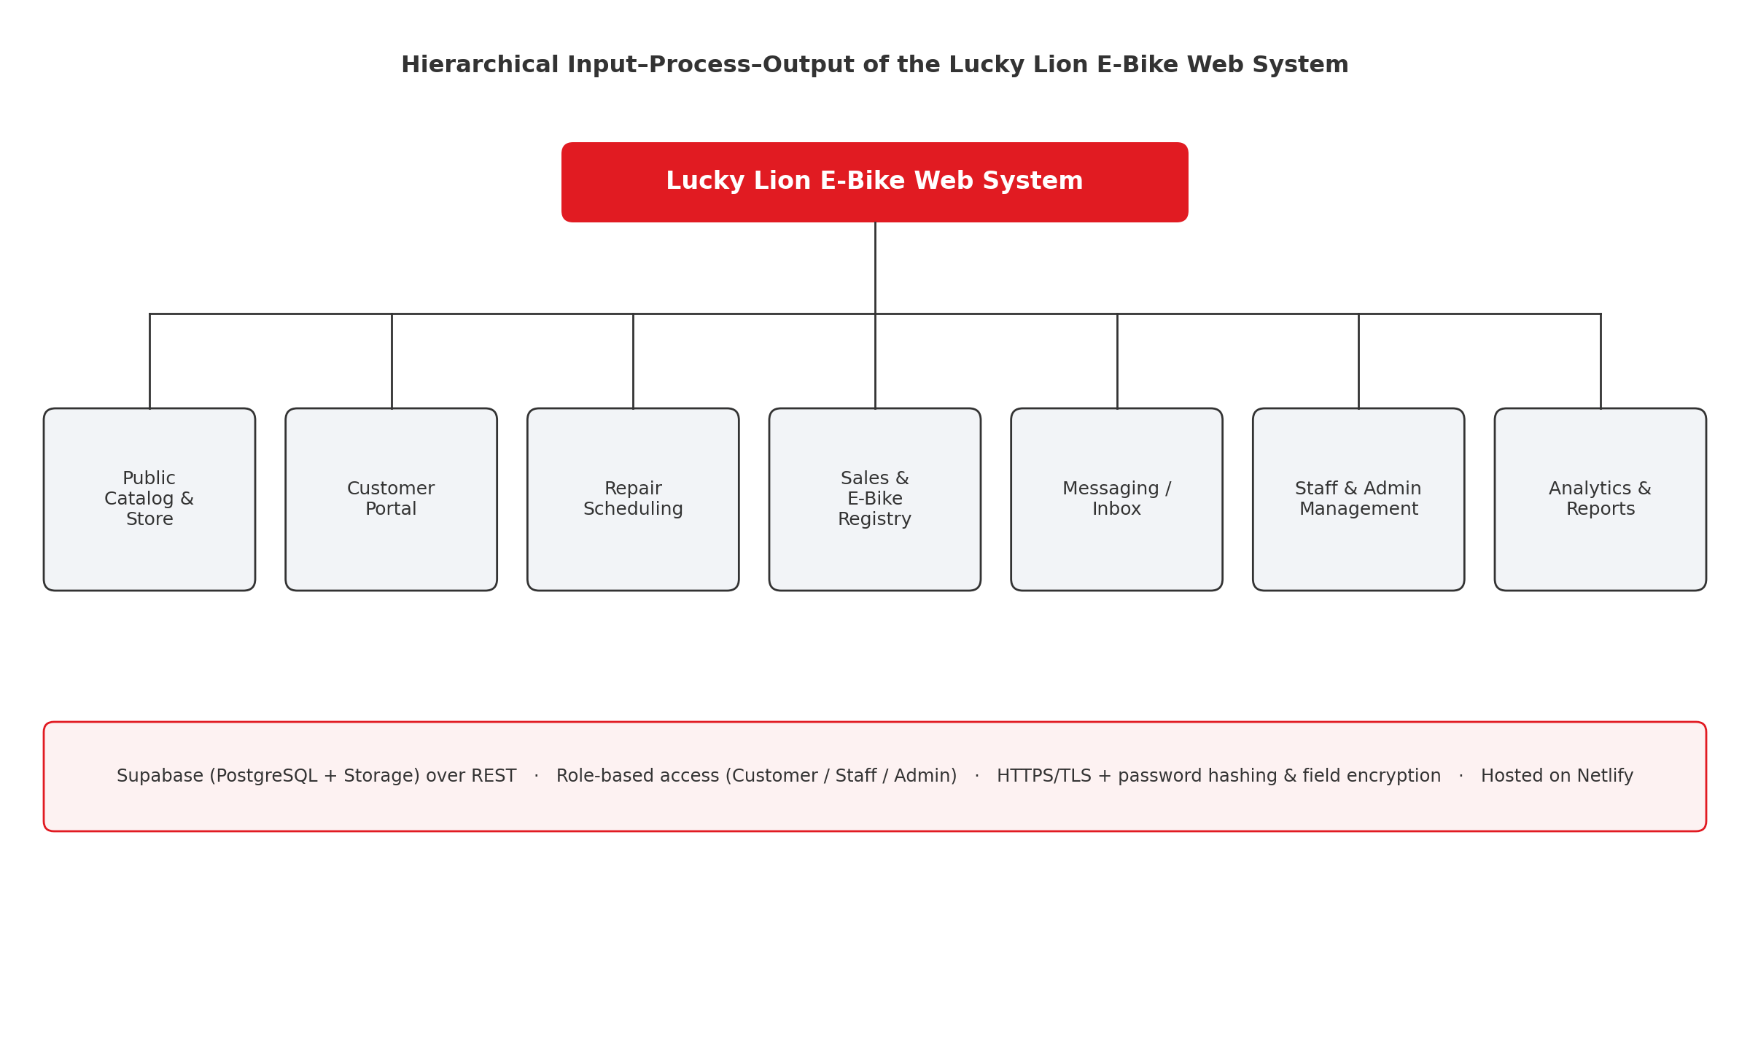
Figure 2. The hierarchical input–process–output structure of the Web-Based Sales, Inventory, and Repair Management System for Lucky Lion E-Bike.
Figure 3 presents the use case diagram of the system, illustrating the interactions between its three actors — the Customer, the Staff, and the Administrator — and the system's core functions. The Customer browses the catalog, creates and manages an account, keeps a record of the units they own, schedules repairs, and messages a branch. The Staff manages their own branch's customers, records and updates repairs, maintains the branch's entries in the e-bike registry, and replies to customer messages. The Administrator oversees all nine branches, manages the product catalog, store photographs, and site settings, reviews repair and messaging analytics, and creates the staff and administrator accounts used throughout the organization.
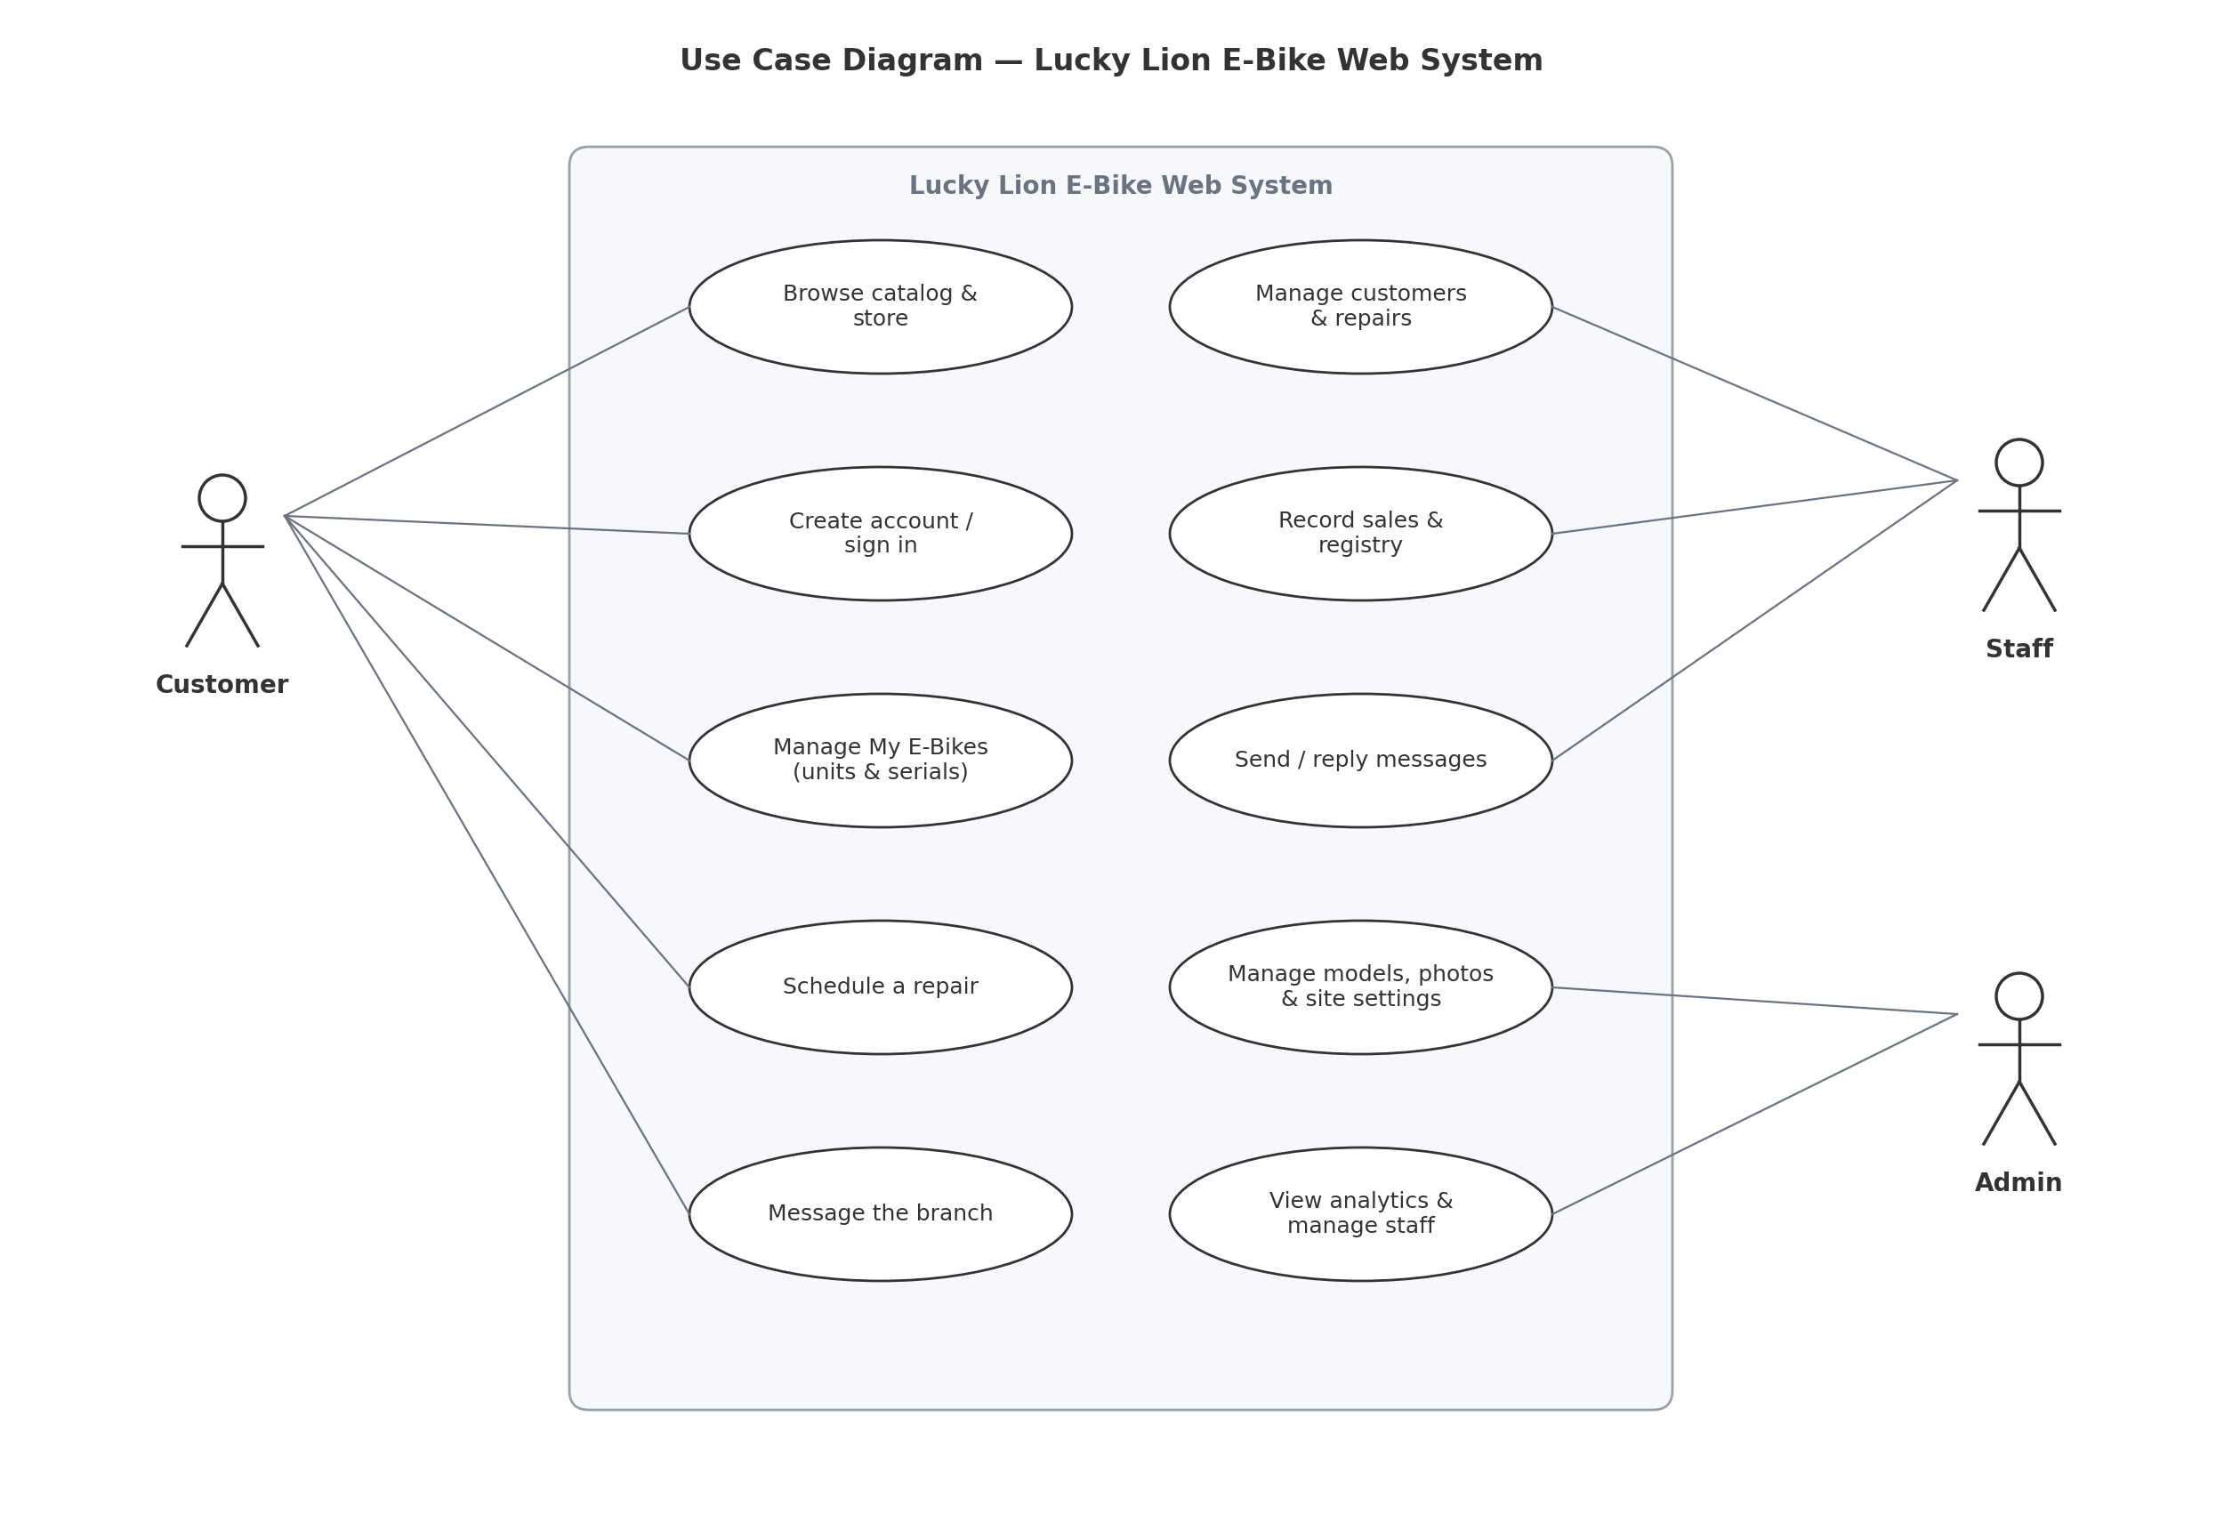
Figure 3. Use case diagram of the Web-Based Sales, Inventory, and Repair Management System for Lucky Lion E-Bike.
Requirement analysis. The researchers gathered information on the current operations of Lucky Lion E-Bike across its nine branches in Cavite. At present, each branch keeps its own records of customers, sold units, and repairs using notebooks and separate spreadsheets, so that management has no consolidated view of the company's customers, sales, or after-sales service, and customers themselves have no reliable online means of browsing the catalog, registering the units they own, or booking a repair. From this analysis, the following core modules of the system were defined.
Public Catalog and Store Module. This module presents the business's e-bikes organized by wheel type, with each model shown together with its specifications, photographs, and available colour variants, and with the price displayed on the model's product-detail page. It also lets any visitor find the branch nearest to them, so that the catalog serves both as a browsing tool and as a bridge to an in-person visit.
Customer Portal Module. This module allows customers to create an account, sign in, and maintain a “My E-Bikes” record of the units they own — including the colour of each unit and its chassis, battery, and motor serial numbers — and serves as the customer's entry point to online repair scheduling and to the messaging channel with their branch.
Repair Scheduling and Messaging Module. This module lets a customer book a repair online, with the system enforcing a limit of one booking per time slot per day so that appointments never conflict, and provides a two-way messaging channel between the customer and their branch for inquiries, follow-ups, and after-sales support.
Sales Recording and E-Bike Registry Module. This staff module records each sale by assigning a purchased unit to its customer — capturing the unit's colour and its chassis, battery, and motor serial numbers — and maintains a consolidated registry of every unit sold across all of the branches. Because each unit's ownership and identifying details are recorded in one shared place, no sold unit is ever lost track of, ownership can be readily verified, and the servicing history of any individual unit can be traced.
Administration and Analytics Module. This module gives administrators company-wide oversight of all nine branches, presenting repair and messaging analytics that summarise activity across the network, together with sole control over the product catalog, store photographs, and site settings, including the creation of staff and administrator accounts.
Security Module. Cutting across all of the other modules, this component enforces role-based access control and data encryption throughout the system, transmitting all information over HTTPS/TLS and protecting passwords and other sensitive fields through hashing and encryption so that each user reaches only the functions and records appropriate to their role.
System Development
The development of the system adopted the Agile model with seven iterative stages, namely Plan, Design, Develop, Test, Deploy, Review, and Launch (Guerrero-Ulloa, Rodríguez-Domínguez, & Hornos, 2023). Figure 4 shows the graphical illustration of the Agile model.
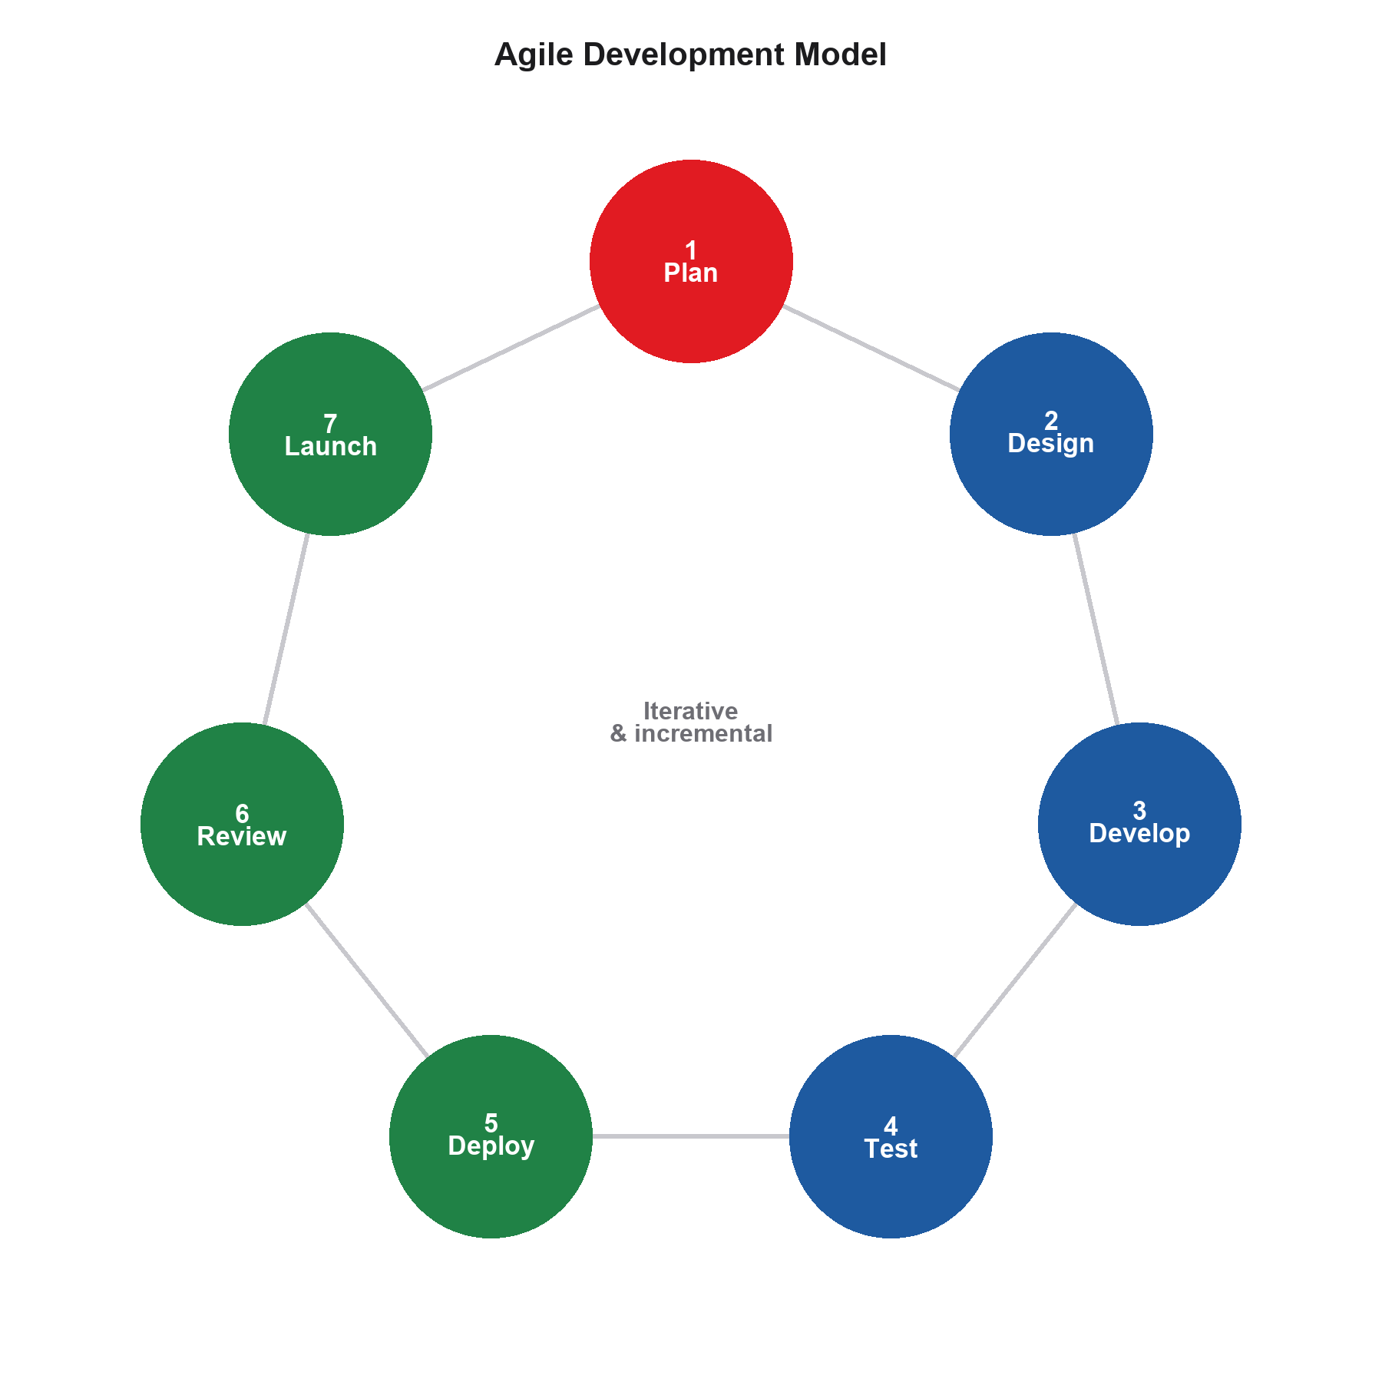
Figure 4. Agile model followed in the development of the Web-Based Sales, Inventory, and Repair Management System for Lucky Lion E-Bike.
Plan. In the planning stage, the researchers conducted a requirements analysis with Lucky Lion E-Bike, identifying the problems of isolated per-branch records and the absence of an online storefront and customer portal. The core objectives were set and the technical stack — HTML, CSS, and JavaScript with a Supabase (PostgreSQL) backend hosted on Netlify — was finalized.
Design. In the design stage, the researchers mapped out the user interface and user experience for the public store, the customer portal, and the staff and administrator dashboards, and designed the database schema for the users, the models and their colour variants, the owned units, the repairs, and the messages, along with the role-based access rules that govern each type of user.
Develop. In the development stage, the researchers built the front-end pages in HTML, CSS, and JavaScript and connected them to the Supabase backend over its REST interface, implementing each module and applying the security measures, including HTTPS/TLS and password hashing.
Test. In the testing stage, the system underwent unit testing of individual features, integration testing of the connection between the front end and the Supabase database, and system testing of the platform as a whole to ensure records are stored and retrieved correctly and access rules are enforced.
Deploy. In the deployment stage, the system was published to Netlify and connected to the live Supabase database, and staff and customer test accounts were set up so that a pilot group could use the system in a realistic environment.
Review. In the review stage, the researchers gathered feedback and performance observations from the pilot group, using them to correct defects and refine the interface and workflows before the final evaluation.
Launch. In the launch stage, the finalized system is prepared for full use by Lucky Lion E-Bike, including the execution of the implementation plan, the setup of branch staff and administrator accounts, and orientation for staff on managing their branch through the system.
System Testing
The system will be tested to ensure that all of its modules — the catalog and store, the customer portal, repair scheduling, messaging, the e-bike registry, and the administration and analytics features, together with the underlying security measures — function correctly under a range of conditions. To achieve a comprehensive evaluation, the researchers will involve three IT professionals to assess the backend stability, code efficiency, access control, and database security of the system, and three users drawn from branch staff and customers to assess its practical usefulness in real branch operations. The testing procedure involves the following.
Unit Testing. Each individual feature — such as registering an owned unit, recording a sale in the e-bike registry, or booking a repair slot — is tested on its own to confirm that it performs its function correctly and validates its input as expected.
Integration Testing. The connection between the front-end pages and the Supabase (PostgreSQL) backend is tested to verify that data is stored and retrieved accurately and without excessive delay, and that changes made in one branch are reflected in the shared database.
System Testing. The entire system is tested as a whole to ensure that navigation is intuitive, that role-based access correctly separates customer, staff, and administrator functions, and that the security measures protect data across the platform.
3 IT Professionals. To evaluate the system's backend stability, code efficiency, access control, and database security.
3 Branch Staff and Customers. To evaluate the system's practical usefulness and ensure the interface is easy to use in real branch and customer scenarios.
System Evaluation
The system will be evaluated using the ISO/IEC 25010 evaluation instrument with the indicators of Functional Suitability, Performance Efficiency, Compatibility, Usability, Reliability, Security, Maintainability, and Portability (International Organization for Standardization, 2023). The evaluation will be conducted with a total of 50 respondents, consisting of 10 IT professionals and 40 staff and customers of Lucky Lion E-Bike drawn from across its Cavite branches, so that both the technical soundness and the everyday usability of the system are assessed.
Functional Suitability. Measures whether the system provides all of the functions required of it — the catalog and store, the customer portal, repair scheduling, messaging, the e-bike registry, and the analytics features — and whether those functions genuinely meet the needs of the business and of its customers.
Performance Efficiency. Assesses how quickly pages load and records are retrieved, and how well the system uses resources under normal use.
Compatibility. Ensures the system runs correctly across common web browsers and on both computers and smartphones of different screen sizes.
Usability. Evaluates how easily customers and staff can learn and use the system to accomplish their tasks with minimal effort.
Reliability. Focuses on the system's stability and its ability to operate consistently and recover gracefully from interruptions.
Security. Verifies that data is protected through encryption and that role-based access control prevents unauthorized access to accounts and records.
Maintainability. Assesses how easily the system can be updated — for example, adding models, adjusting prices, or updating branch details — without disrupting operations.
Portability. Measures how easily the system can be accessed and deployed across different devices and environments, given that it is web-based and cloud-hosted.
Data analysis plan. For the analysis of the data, Table 2 shows the descriptive interpretation of the mean. The ratings given by the respondents on the ISO/IEC 25010 evaluation instrument will be tallied and averaged, and the resulting mean interpreted using the scale below.
Numerical Scale | Interpretation
4.51 – 5.00 | Excellent
3.51 – 4.50 | Very Good
2.51 – 3.50 | Good
1.51 – 2.50 | Fair
1.50 – below | Poor
Table 2. Descriptive interpretation of the mean.
Implementation Plan
Table 3 shows the implementation plan for the deployment of the Web-Based Sales, Inventory, and Repair Management System for Lucky Lion E-Bike.
Strategy | Activity | Persons Involved | Duration
Administrative Authorization | Formal submission and signing of approval letters authorizing system deployment and use of business data. | Researchers and Lucky Lion E-Bike Management | 1 Day
Infrastructure & Account Setup | Configuration of the Supabase (PostgreSQL) cloud database and Netlify hosting, and creation of branch staff and administrator accounts. | Researchers | 2 Days
Data Migration | Encoding of the existing product models, customer accounts, and sold-unit records into the system's database. | Researchers and Lucky Lion E-Bike Staff | 3 Days
System Deployment & Orientation | Publishing of the live system and orientation of branch staff and administrators on managing the catalog, sales records, and repairs through the platform. | Researchers, Lucky Lion E-Bike Staff, and Management | 1 Day
Table 3. Implementation plan.
References
Atherton, H., Eccles, A., Poltawski, L., Dale, J., Campbell, J., & Abel, G. (2024). Investigating patient use and experience of online appointment booking in primary care: Mixed methods study. Journal of Medical Internet Research, 26, e51931. https://www.jmir.org/2024/1/e51931
Beck, K., Beedle, M., van Bennekum, A., Cockburn, A., Cunningham, W., Fowler, M., … Thomas, D. (2001). Manifesto for agile software development. https://agilemanifesto.org/
Davis, F. D. (1989). Perceived usefulness, perceived ease of use, and user acceptance of information technology. MIS Quarterly, 13(3), 319–340. https://doi.org/10.2307/249008
Education and Information Technologies. (2021). Evaluating the effects of responsive design on the usability of academic websites during the pandemic. Springer. https://link.springer.com/article/10.1007/s10639-021-10650-9
Fielding, R. T. (2000). Architectural styles and the design of network-based software architectures [Doctoral dissertation, University of California, Irvine]. https://ics.uci.edu/~fielding/pubs/dissertation/top.htm
Google. (2024). Learn responsive design. web.dev. https://web.dev/learn/design/
Guerrero-Ulloa, G., Rodríguez-Domínguez, C., & Hornos, M. J. (2023). Agile methodologies applied to the development of Internet of Things (IoT)-based systems: A review. Sensors, 23(2). https://www.ncbi.nlm.nih.gov/pmc/articles/PMC9866354/
International Energy Agency. (2024). Global EV outlook 2024. https://www.iea.org/reports/global-ev-outlook-2024
International Journal of Industrial and Production Engineering. (2024). Development of a web-based inventory management system for small businesses, 2(2). https://journals.unizik.edu.ng/ijipe/article/view/4096
International Organization for Standardization. (2023). ISO/IEC 25010:2023 — Systems and software engineering — Systems and software Quality Requirements and Evaluation (SQuaRE) — Product quality model. https://iso25000.com/index.php/en/iso-25000-standards/iso-25010
Jan, S. U., Shah, K., & Mand, N. (2023). Point of sale system. SSRN. https://papers.ssrn.com/sol3/papers.cfm?abstract_id=4368998
Ken Research. (2025). Philippines electric two-wheeler market share, companies & trends report 2025–2031. https://www.kenresearch.com/industry-reports/philippines-ev-two-wheelers-market
Matlombe, L., Vuko, S., Thango, B., & Nethanani, R. (2024). Customer relationship management (CRM) systems and their impact on SMEs performance: A systematic review. SSRN. https://papers.ssrn.com/sol3/papers.cfm?abstract_id=4997314
Mozilla. (2026a). CSS: Cascading Style Sheets. MDN Web Docs. https://developer.mozilla.org/en-US/docs/Web/CSS
Mozilla. (2026b). HTML: HyperText Markup Language. MDN Web Docs. https://developer.mozilla.org/en-US/docs/Web/HTML
Mozilla. (2026c). JavaScript. MDN Web Docs. https://developer.mozilla.org/en-US/docs/Web/JavaScript
National Institute of Standards and Technology. (2023). Digital identity guidelines: Authentication and lifecycle management (NIST Special Publication 800-63B). https://pages.nist.gov/800-63-3/sp800-63b.html
Netlify. (2024). Netlify documentation: Deploy and host modern web projects. https://docs.netlify.com/
Nielsen, J. (2020). 10 usability heuristics for user interface design. Nielsen Norman Group. https://www.nngroup.com/articles/ten-usability-heuristics/
Official Gazette of the Republic of the Philippines. (2022). Republic Act No. 11697: An act providing for the development of the electric vehicle industry (Electric Vehicle Industry Development Act). Government of the Philippines. https://www.officialgazette.gov.ph/downloads/2022/04apr/20220415-RA-11697-RRD.pdf
OWASP Foundation. (2021). OWASP Top 10:2021 — The ten most critical web application security risks. https://owasp.org/www-project-top-ten/
OWASP Foundation. (2024a). Password storage cheat sheet. OWASP Cheat Sheet Series. https://cheatsheetseries.owasp.org/cheatsheets/Password_Storage_Cheat_Sheet.html
OWASP Foundation. (2024b). Transport Layer Security cheat sheet. OWASP Cheat Sheet Series. https://cheatsheetseries.owasp.org/cheatsheets/Transport_Layer_Security_Cheat_Sheet.html
Shayan, P., Rondinelli, R., van Zaanen, M., & Atzmueller, M. (2023). Multi-level analysis of learning management systems' user acceptance exemplified in two system case studies. Data (MDPI), 8(3). https://www.mdpi.com/2306-5729/8/3/45
Supabase. (2024). Supabase documentation: The open source Firebase alternative. https://supabase.com/docs
Taylor & Francis. (2021). The importance of e-commerce adoption and entrepreneurship orientation for sustainable micro, small, and medium enterprises. https://www.tandfonline.com/doi/full/10.1080/21665095.2021.1976657
The PostgreSQL Global Development Group. (2024). PostgreSQL 16 documentation. https://www.postgresql.org/docs/
W3C Web Accessibility Initiative. (2023). WCAG 2 overview. World Wide Web Consortium. https://www.w3.org/WAI/standards-guidelines/wcag/

